ARC Project Proposal

Large and Complex Software Project Planning

Objective
This project involves development of a model for large complex software projects enabling:
- the prediction of required time and budget for the project at any point in time
- the ability to continuously improve the model based on historical data

Description
While in traditional project management (such as encountered in construction or traditional manufacturing industries, and also parts of the software development industry) execution can be modelled well through:
- detailed breakdown of tasks
- detailed dependencies between tasks known in advance
- uniquely defined sequences of tasks

In large complex software projects these simplifying constraints do not apply anymore:
- detailed breakdown of tasks is not desirable (considering the cost of creating the breakdown to the benefit the breakdown provides)
- detailed dependencies between tasks are not known in advance, but islands of dependencies exist
- requirements are changing frequently also as a result of completion of tasks
- tasks are constantly being refined
- there are high degrees of uncertainty attached to the number of required tasks and their required effort
- there is a significant number of expected but unplanned tasks implicitly resulting from defects
- there are expected but unplanned tasks such as defects
- there are many possible sequences of tasks to deliver the project

The goal of this project is to create project calculator which can predict the future evolution of the project, in order to provide the best possible status of the project and enable early corrective actions around scope, timelines and budget.

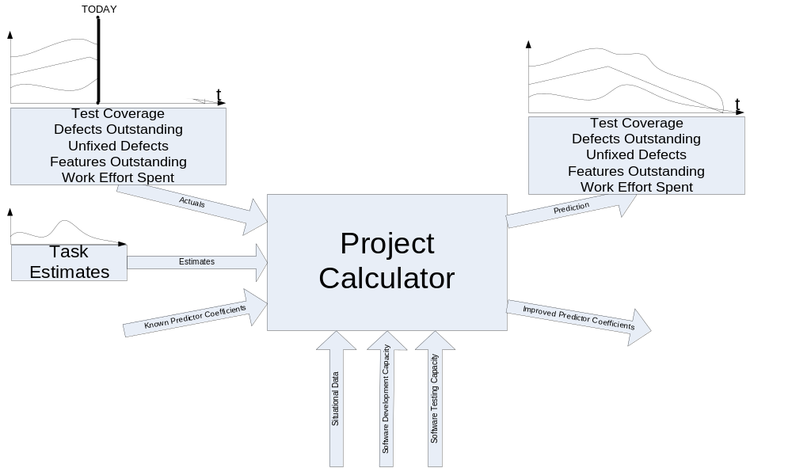

Key Technical Challenges
- The available input data used by the project calculator must be minimal and limited to what can easily be retrieved with minimum burden on the project participants. In this context of incomplete information the calculator still needs to represent reality with a sufficient level of accuracy during the entire life-cycle of the project.
- There are many parameters which have to be set into a relationship (task estimates, defects, capacity for developers, capacity for testers, test coverage, etc.). E.g. a developer can either spend time during on the development of new tasks or on the fixing of defects, what is the relationship between implemented tasks and number of defects identified, what is the relationship to test coverage to identified defects, what is the relationship to number of defects and effort required to fix them?

Desired Outcomes
- a clear description of the project calculator explaining the semantics of its input and outputs, and the internal processing
- a proof of the correctness and optimality of the model
- an implementation of the model, preferably through a spreadsheet, or through another readily available modelling tool.

Business Objects Contact
Philipp Ziegler

